U10
10” Two Way Full Range Plastic Speaker

Product Description:  Portable and installed plastic loudspeakers used in applications including sound reinforcement in Front of House and Foldback applications in Houses of Worship,Events, Clubs, Rehearsal Halls etc. The U Active Series delivers extraordinary performance at unmatched value.  Key Features and Benefits:  - High output SPL and sensitivity  - 1 x 10” high power transducer with 50mm voice coil  - 1 x 1.3” diaphragm compression driver  - 90º x 60º controlled coverage pattern  - Rotatable Horn  - Heavy duty protective grill  - Injection molded  - 2 x NL4 connector  - Cabinet design for FOH and Monitor use  - Suitable for use as a main system with or without sub speaker augmentation  - Portable system (stand), or permanent installation (wall, ceiling, under balcony)Arrays with all active high power U Series sub speakers for extended low frequency, high quality music reproduction  - Monitor kit - optional  Cabinet Dimension:  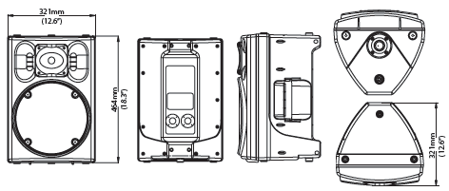  Installation drawing:  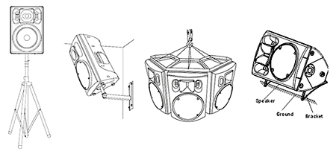
  Specifications
  Construction | Plastic
  Transducers | 1 x 1.3”HF+1 x 10”LF
  Frequency Response (-3dB) | 65Hz-18kHz
  Rated Power | 250W(RMS)
  Sensitivity (1W @ 1m) | 95dB
  Maximum SPL (1W @ 1m) | 119dB(Peak)
  Rated Impedance | 8Ω
  Dispersion (HxV ) | 90°x60°
  Connector | 2xNL4
  Dimensions (WxDxH) | 321mm (12.6”) x 321mm (12.6”) x 464mm (18.3”)
  Dimensions (WxDxH) | 375mm (14.8”) x 355mm (14”) x 535mm (21.1”)
  Net Weight (1 piece/pack) | 10kg (22lb)
  Gross Weight (1 piece/pack) | 12kg (26.5lb)
  Mouseover image to zoom
  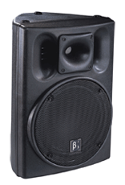
  Relevant Download:
  U Series Catalog
  User Manual
  U10 Image

