EQ2231
Stereo Graphic Equalizer

Product Description:  The EQ2231 is a 3U 30 band, constant Q Stereo Graphic Equalizer.  Key Features and Benefits:  - EQ filter is bypassed if fader is in centre indent position  - In the event of power failure a high quality relay switch sends input signal directly to output connectors  - Power-on delay for soft start  - Front Panel  2 x 30 constant Q faders ±15dB control range  9 x segment signal output LEDs  Gain control  High pass filter up to 250Hz  Low frequency shelf filter ±6dB of gain at 50Hz  High frequency shelf and filter ±6dB gain 14kHz  EQ bypass switch  - Rear Panel  2 x Balanced XLR input connectors  2 x Balanced XLR output connectors  6.5mm inputs and outputs connectors  Phoenix inputs and output connectors  Front Panel:  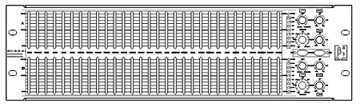  Rear Panel:  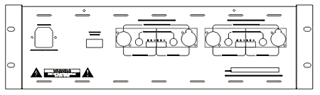
  Specifications
  Input Impedance | 10kΩ Balanced and Unbalanced
  Overloaded Electromotive Force | 8.5V
  Frequency Response (±1dB) | 5Hz-45kHz
  Harmonic Distortion | <0.008% THD 20-20kHz
  S/N Ratio | >92dB
  Max. Output Level | 9.5V
  Output Impedance | <50Ω
  Dynamic Range | >115dB
  Crosstalk | >85dB @ 1kHz
  Frequency Control | ±15dB on ISO centres Q value for 4
  Power Supply | 220V 50Hz
  Dimensions (W x D x H) | 483mm (19”) x 228mm (10”) x 45mm (1.8”)
  Net Weight (1 piece/pack) | 4.7kg (10.4lb)
  Gross Weight (1 piece/pack) | 6.3kg (13.9lb)
  Mouseover image to zoom
  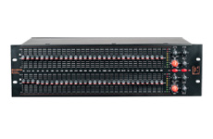
  Front View Back View

