C223+
Active Crossover

Product Description:  The C223+ is a 1U Stereo two-way/mono three-way active crossover.  Key Features and Benefits:  - Front Panel  2 x Input gain control  2 x Low/high frequency selector  2 x Low output gain control  2 x High output gain control  2 x Phase inversion switch  2 x 40Hz low cut switch  - Rear Panel  2 x Balanced XLR input connectors  4 x Balanced XLR output connectors  Two-way stereo or three-way mono crossover via switch  - Switch to select normal or summed low frequency output  - Switch to select between 1x or 10x frequency  System Specifications:  System Two way - Three way Crossover  Front Panel & Rear Panel:  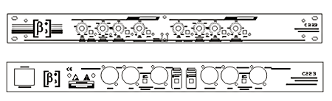
  Specifications
  System | Two way - Three way Crossover
  Harmonic Distortion | <0.004% @ +4dB, <0.04% @ +20dB, 1kHz
  Channel Crosstalk | <-80dB 20Hz-20kHz
  Crossover Point | 45Hz-960Hz adjustable or 450Hz-9.6kHz adjustable
  Frequency Response (±0.3dB) | <3Hz - >90Hz, +0/-3dB
  Dynamic Range | >106dB unweighted, all outputs
  Power Supply | 220V ±10%/50Hz
  Dimensions (W x D x H) | 483mm (19”) x 175mm (6.9”) x 45mm (1.8”)
  Packaging Dimensions (1 piece/pack) | 550mm (21.7”) x 225mm (8.9”) x 55mm (2.2”)
  Net Weight (1 piece/pack) | 1.7kg (3.74lb)
  Gross Weight (1 piece/pack) | 2.5kg (5.5lb)
  Mouseover image to zoom
  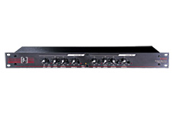
  Front View Back View

